Activities for use with Orpheus Speaks: The Greatest Greek Myths You Never Heard, by Tracy Barrett
Teachers, librarians, parents: feel free to use any of these activities for your personal use. All pages are copyrighted, but you may duplicate them for classroom use. For any other use, please write to me for permission.

I check the links periodically to make sure they’re active but if you find any that don’t work, please let me know at TracyTBarrett@yahoo.com. I would love to learn what worked, what didn’t work, and any other ideas you have to offer!

Crafts
Use markers, paint, felt, googly eyes, etc. to decorate rocks as the gods or mythological characters of your choice. You could also use craft store products like paper plates or foam backing or wooden figures as a base, but rocks are free and the irregular shapes often lead to comical versions!
Create a comic strip based on mythology. You can print out blank comic templates (there are many on-line) and have the kids use pencil/markers/glued embellishments. To make the comics more ancient-world-centric, find existing comics set in Rome or Greece (for example, Asterix), make one copy, white out the words, and make as many copies as you need. Two drawbacks: although my sources tell me that this is not a copyright infringement if you don’t sell them, I’m not a lawyer and can’t swear to the accuracy of this statement; and it locks your students into certain plots/situations because of the attached drawings.

Make “Pan pipes” out of drinking straws (see instructions). I discovered through trial and error that the way to get the most sound out of them (although you don’t get much, which could be a good thing!) is to blow across the top the way you would blow across an empty soda bottle to get that “foghorn” sound.

Show the students images of some Greek vases (for example, search Google images for “greek vases,” and be sure to examine your choices carefully for nudity or other issues!). Download an outline of a Greek vase here or here (click on the “download” button). Have the students to decorate a vase, either with humans/animals or geometric designs.

If the budget allows, purchase small terracotta flower pots at a craft store. Using black paint or black markers, decorate them as Greek vases.

Writing skills
If your life were a Greek myth, what would it be? Write a brief paragraph describing your epic journey so far. For help, here’s a step-by-step “how-to” on writing a myth.

It’s sometimes hard to visualize the pictures that the Greeks saw in the constellations. This star map shows the outlines of the most familiar constellations. On the last page of this handout is a map of a part of the night sky (Northern Hemisphere). Ask the students to find a cluster of stars that makes a shape for them, and then write their own myth about how that person (animal, object, etc.) wound up in the sky as a constellation. For more on constellations, here’s a free printable lesson plan. Also see Lesson 1, below.

Resources
Free printable coloring pages, crosswords, worksheets, etc.

Free 12-week mythology study guide.

Lots of activities on a homeschooling mother’s blog.

10-page Greek mythology study packet.

Greek Mythology lesson plans

Overview
Students typically start learning about Greek mythology in fourth grade, with more in-depth study in fifth grade and then throughout their education. Despite this high level of exposure in school, and the exposure from popular culture (video games, books and film [e.g., the “Percy Jackson” series], cultural references, etc.), many myths remain unfamiliar to students. In addition to being enjoyable and instructive in and of themselves, myths can easily be used in interdisciplinary studies in conjunction with many other subjects.

Lesson 1: Constellations

Learning Objectives
After completing this lesson, students will be able to:
- Understand some facets of the ancient Greek value system and what character traits they admired
- Identify some of the important constellations, as defined by the Greeks
- Create their own constellation
- Write a myth exemplifying what they consider a positive character trait
- Use their imaginations to envision images from points on a background

Materials
- A chart showing some of the most important constellations
- A chart showing the night sky

Have the students read (or tell them) the stories behind two or three of the most important constellations. Examples: Ursa Major and Minor, Orion, Heracles, Andromeda. Elicit from the students what each person or animal did to deserve being placed in the heavens.

Show students a constellation to show that a viewer needs to use a lot of imagination to see a shape in the cluster of stars. Either individually or in groups, the students will then examine a chart showing the night sky and find similar clusters that “look like” something.

Students will then be given a few minutes (the amount of time depends on how much is available) to write a synopsis of a myth explaining what that person (animal, etc.) did to merit being remembered in this way.

Additional constellation work:
- Math skills: Students graph the points of their constellations on a standard X- and Y-axis graph.
- Multicultural knowledge: Have students research what the stars and the shapes they make represent in cultures other than ancient Greece and those influenced by ancient Greece.
- History: Students research how navigators used the stars to find their way across deserts and oceans.
Geography: Show the students the night sky as seen in the southern hemisphere, where the stars and constellations are completely different from what they see from the northern hemisphere.
CONSTELLATIONS ACTIVITY

My name: ___________________________________________________

My constellation’s name: _______________________________________

The story behind how my constellation got placed in the sky:

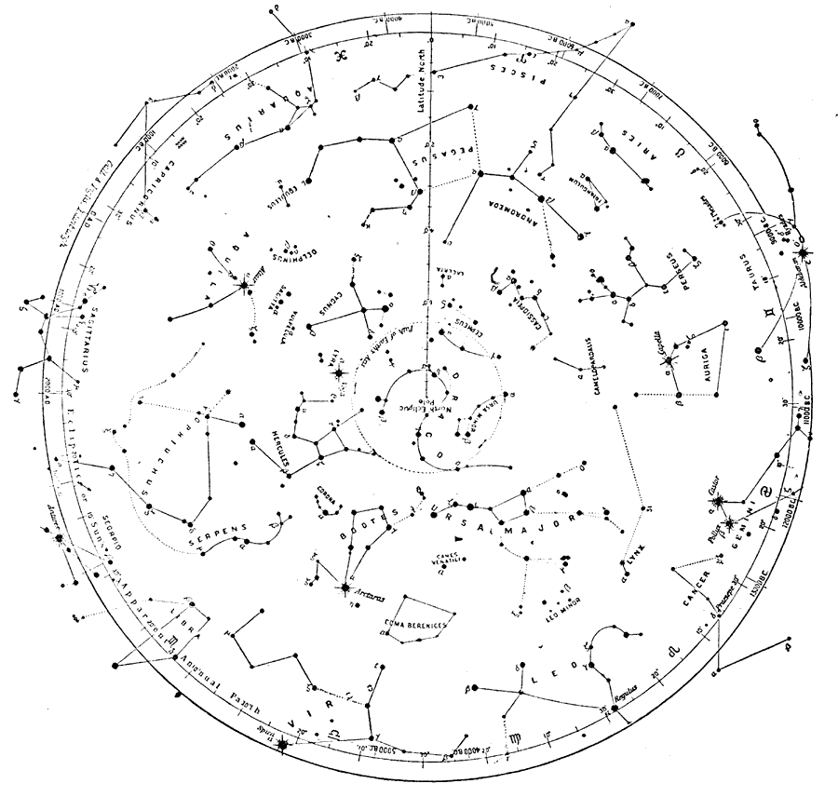

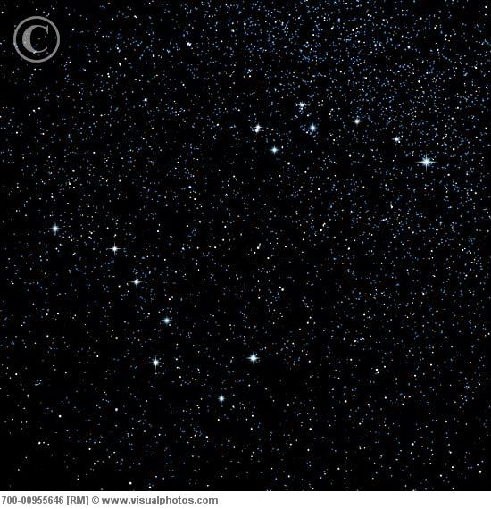
Lesson 2: Where words come from

Many words in English, Spanish, German, and other languages derive from ancient Greek, either directly, or through Latin (which adopted and “romanized” many Greek words). If you know the meaning of the origin words, you can sometimes guess what the modern word means.

Learning Objectives
After completing this lesson, students will be able to:
- Identify the Greek origin of many words
- Understand how languages connect with one another
- Improve their spelling of English words based on Greek
- Be able to deduce the meaning of many English words

Introduce the Greek alphabet to students, using the chart in the appendix of The Song of Orpheus or some other source. Discuss how many Greek words were changed when they were adopted by Latin, and that many English words show a Latin form rather than a Greek one.

Give them these general rules of thumb (note that there are exceptions!) to tell if an English word derives from Greek:

The letter “h” is sometimes a clue, even though there is no Greek letter for “h”! A word that starts with an “h” in English starts with what looks like a backward apostrophe (a rough-breathing mark) in Greek. For example, Ἑλένη is “Helena” or Helen. If it starts with a vowel with a regular-looking apostrophe (a smooth-breathing mark), there is no “h” sound. For example, Ἐπιμηθεύς (Epimetheus).

The ancient Greeks probably pronounced their letter χ like a “k” with an “h” immediately after it, and the Romans wrote that as “ch.” The Greeks probably pronounced their letter φ like a “p” with an “h” immediately after it, and the Romans wrote that as “ph.” In English, most of the Greek words that were spelled with a χ are spelled with “ch” and are pronounced like “k.” The Greek letter φ, spelled by the Romans and also by us as “ph,” is pronounced like “f” in English. So most words that include “ph” are Greek, as are words that include “ch” when it’s pronounced like “k.” Same with the letter ῥ (when ρ is the first letter of a word, it always has a rough-breathing mark). Examples: telephone, chemistry, rhinoceros.

Some combinations with “h” almost guarantee a Greek origin: rrh, phth, chth. Examples (these aren’t very common words!): catarrh, diphtheria, autochthonous.

When the letter “y” comes between two consonants, the word very likely has a Greek origin.

Most (but not all!) English words with a “z” come from Greek.

Words from Greek: Question set 1

Which of these words do you think come from Greek? Underline the letters that make you think that:

alphabet
bronze
chronicle
courtyard
humanity
hybrid
mischief
myth
overhear
perhaps
prophecy
rhinoceros
royal
shepherd
style
superhero
sympathy
touch
zipper
zodiac

Words from Greek: Question set 2

1. Since Orpheus was a famous performer, what kind of activity do you think goes on in an orpheum?

2. Titans were huge beings. What famous ship was named for them because it was so big?

3. If Argonauts sailed on a ship called the Argo, and “astro” comes from a word meaning “star,” what do you call someone who “sails” among the stars?

4. “Pandora” means “all gifts.” If “eu” means “well” or “good,” what does the name “Eudora” mean?

5. The Greek hero Heracles was the strongest man on earth (mostly because he was only half man; his mother was a human but his father was Zeus, the king of the gods). His name in Latin was “Hercules.” If you call someone “Herculean,” what are you saying about that person?

6. The Hydra was a monster with many heads. When you cut off one of its heads, it sprouted one or more new heads in its place (read the myth of the “Twelve Labors of Hercules” to find out how to stop this from happening). What do you think is meant if someone refers to a problem as being like the Hydra?

7. In all languages, the meanings of some words change over time. The Greek word νύμφη (“nymphe,” or “nymph” in English) originally meant “bride,” then “girl,” and then a semi-divine girl who symbolized something in nature. That’s what people usually mean when they talk about “nymphs” in English, but there’s also a special meaning to biologists. Find out what that meaning is.

Words from Greek: Question set 3 (challenging!)

Phobos, the Greek god of horror, gave his name to the word “phobia.” A phobia is an unreasonable fear of something that isn’t actually harmful, or of something imaginary, or of something that is potentially harmful, but the phobic is more afraid of it than makes sense. For example, fire can certainly harm you and it makes sense to be cautious with it, but if you’re so afraid of fire that you run away when you see a match, or if you can’t go someplace where there was once a fire, you might be suffering from pyrophobia (the Greek word for fire is “pyr”).

I. Match each phobia with the thing that is feared:

1. acousticophobia _____ a. animals
2. bacteriophobia _____ b. computers
3. cyberphobia _____ c. drugs and medicine
4. mechanophobia _____ d. fear
5. microphobia _____ e. germs
6. pharmacophobia _____ f. injury
7. phobophobia _____ g. light
8. photophobia _____ h. machinery
9. traumatophobia _____ i. small things
10. zoophobia _____ j. sounds

II.
1. If “agora” means “marketplace,” what are people with “agoraphobia” afraid of? (Hint: It’s not the marketplace!)
2. What do you think people are afraid of if they have “hypnophobia”?
3. The Greek word “acropolis” means the “high [part of a] city.” What are acrophobes afraid of?
4. If someone has “decidophobia,” what is he or she afraid of doing?
5. What does a thermometer measure? So what is a thermophobe afraid of?

III. Combine a word (or two words!) from column A and a word from column B to make an English word. Match that word with its definition in column C. Some Greek words are used more than once!

A B C
autos (self) graphein (to write) The order in which things happen/happened
bios (life) kratia (rule, power) An author’s story of her or his own life
chronos (time) logia (theory, science) Big town
demos (the people) polis (city) Clock
mega or megalo (big) sophia (wisdom) Government by citizens
meter (mother) Important town
philos (love) Picture
phos (light) The study of knowledge, values, and reality
The study of living things

All pages © Tracy Barrett, 2016

